WWW.YCP.ORG.MK
2017
EVS INFO PACK
Strategic EVS 01.10.2017 – 30.09.2020 Youth In Action 2.0
Youth Council Prilep
Dear Partners and Applicants,

Through the following pages, we have summarized the information you need to know about your journey to Macedonia and about our Strategic European Voluntary Service Project.

We are very glad that you have decided to apply in this project, and therefore we will strive to offer a warm welcoming to you in Macedonia.

If you have further questions, do not hesitate to contact us

Mile Dimkoski
Program Manager

miled@ycp.org.mk
+389 78 603 454

Enjoy exploring the practicalities!

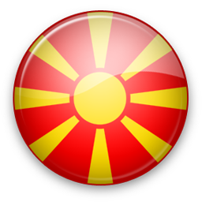
About Macedonia
Macedonia is at the crossroads between Central, Southern and Eastern Europe, between the Balkan Peninsula and the Pannonian Plain.

For more information on the country‟s population, climate, history and culture, please visit:
WIKIMacedonia, Exploring Macedonia, Macedonia

The Republic of Macedonia officially uses the Macedonian language and Cyrillic script. However, on public signs and in the media the Latin script is very often used, and both scripts are taught in school.

Ethnic minorities have the constitutional and legal right to officially use their languages and alphabets in the areas they inhabit.
Citizens ~ 2.000.000
Capital Skopje ~ 550 000
Biggest cities: Kumanovo, Tetovo, Bitola, Prilep, Strumica, Shtip, Veles, Ohrid

Country Code: +389
National Sport: Handball

Weather in Macedonia:
The weather in Macedonia in JUNE is from 20-30 C degrees depends of summer. It also might be rainy. We have also cold winters that sometimes temperature goes to -15 C degrees. You can check more info before coming to Prilep
Food in Macedonia
Travelers talking about Macedonian food

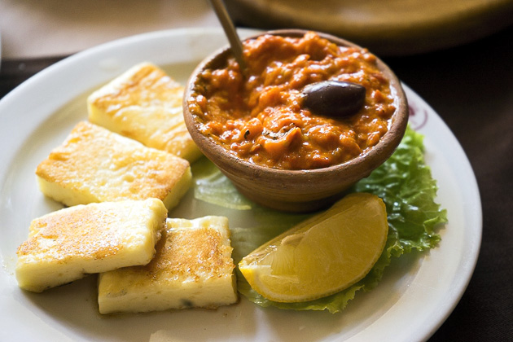

Our currency and prices
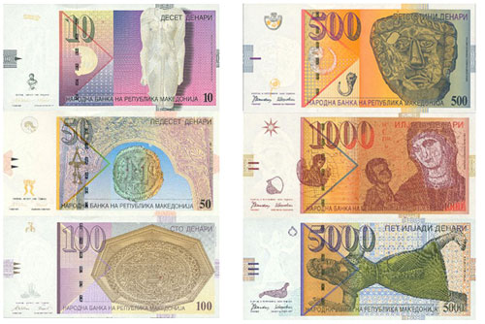

Macedonia‟s official currency is the Denar (MKD). One Euro is approximately 61.3 Macedonian denars. For other exchange rates, check the following website

Notes are in denominations of 10, 50, 100, 200, 500, 1000, and 2000 MKD. Coins are in denominations of 1, 2, 5 and also 10 and 50 MKD. Most of the credit cards are accepted
.
All major currencies may be exchanged in all banks, hotels and exchange offices.
Proportion: 1 Euro = 61.50 MKD;

When you come to Macedonia you will find the new banknotes of 200 and 2 000 MKD.

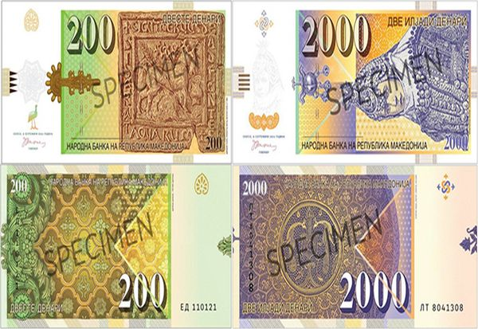

You can change currency at exchange office in hotels, or get Denars right out of the ATM in several places in the town, banks and exchange offices.

NOTE!
You should change or withdraw money when you arrive to Macedonia, in order to buy bus tickets that are available only in Macedonian Denars (MKD).

Here are some examples of local prices:

One coffee at a coffee shop costs 1 €.
One beer in a pub costs 1 €.
One cake in a patisserie costs 1 €.
Two breads in a bakery costs 1 €.

ATMs and Credit Cards

All major banks in Macedonia have automatic teller machines (ATMs) in most towns.
All major credit cards are accepted almost everywhere.

Electricity supply

The electricity supply in Macedonia is 220 volts, a.c. 50 Hz. Sockets are with 2- point plugs, square pin. Many hotels provide adaptors upon request from the reception.
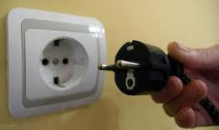

Smoking
Smoking is prohibited in all indoor public places and night clubs.

Local Time
Macedonian Time is GMT +1.

Opening hours
Shops normally open around 09:00 and close around 20:00.
Shops in tourist areas, large shopping centers and department stores may stay open on weekends and public holidays as well.
Banks are open on workdays (Monday to Saturday) usually between 08.30 and 16.30.
Restaurants and cafes have varying opening hours, but lunch is most often served between
12:00 and 15:00. Dinner is served from 19:00 until late in the evening.
About Prilep
Prilep is the fourth largest city in the Republic of Macedonia. It has a population of 80,000 and is known as "The city under Marko's Towers" because of its proximity to the towers of Medieval Prince Marko. The city is also known, The Hero City.
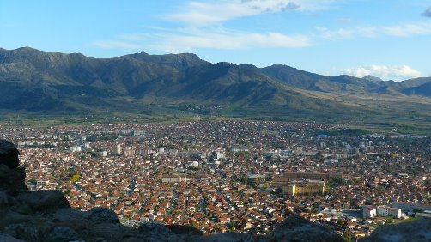
For more information on Prilep, visit: Prilep WIKIPrilep
Trademarks of Prilep
Beer Fest Best Beer in Macedonia Famous Tobacco producers Rare Marble Producers Marko’s Towers Monasteries
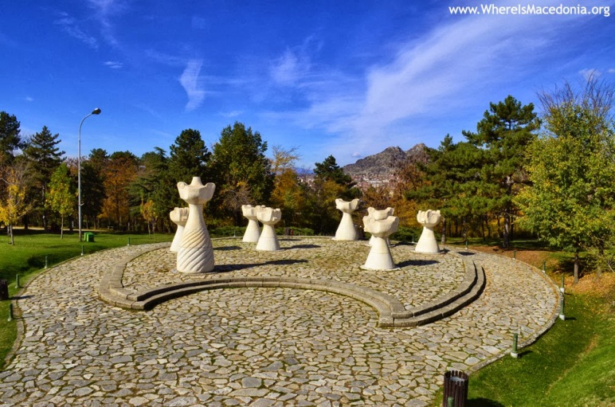

Youth In Action 2.0
Starting date – 1st April 2017 – 29.10.2018 (7 months volunteering assignment)
Project Information
General Information
Youth in Action 2.0 wants to contribute towards Young people actively participate in their community development aiming to enhance youth participation in school communities with inter-cultural dimension.
We focus on Participation as a human right and not a privilege, every individual needs to have opportunity to build better society. Local authorities and youth organizations need to promote opportunities; nevertheless they need to create these opportunities in order to see young people actively participate in community development. If we use the Hart's ladder of young people's participation, current and previous analysis have shown that level of youth participation in Macedonia is still on level of Symbolism Decoration and Manipulation. Insufficient integration of the youth in decision making processes is still the main obstacle that does not allow making appropriate decisions that concern the real needs of all stakeholders.
There are several factors influencing the current situation on youth participation in decision making, with our project we focus on high school students as one dynamic, energetic target group always needing support and empowerment.
YIA2.0 includes Two 7 month and One 6 month EVS activities for 9 volunteers in total ,coming from Romania, Italy and France to Prilep Macedonia in the period November 2017 - June 2020. The volunteers will support Youth Council's Prilep's Youth Participation program. Each EVS phase will include one volunteer per country.
The objectives of the EVS assignments are:
- To provide continuous support to school organizations by EVS international volunteers within YCP facilities.
- To increase the mobility of 9 young people from Romania, Italy and France
- To increase the outreach of young people consulted by YCP
- To raise the awareness on voluntarism, cultural exchanges and dialogue through direct contact with the local population;
The three mobility phases are identical and complementary one to another

Tasks
The volunteers will carry out following general activities:
- will assist in project development and implementation of project activities with high school students visiting YCP
- will assist in creation and implementation of yearly programs of school organizations
- will gather information and data once per month from 5 high school organizations
- will create brief documents on information gathered from high school students in Prilep.
- prepare articles and reports and update organization web site
- participate in meetings, promotion and other social events (twice a month)
- organize presentations/workshops to young people (at least twice a month)
During the realization of the activities the volunteers will have full support from the organization team and the rest of the volunteers. He will have full freedom to bring initiatives and modify the tasks in direction to his/her learning processes.
In coordination with the program manager of the organization and the program assistants, the volunteers will implement the tasks.

Working time
Regarding the working time, working days are Monday-Friday. Saturday and Sunday are non-working days. During national holidays the organization is not working. We will respect and the holidays that the volunteers are celebrating in Italy as well. It is also important to us as host organization but also as for the volunteers to follow and evaluate their learning process. We consider that this is especially important for the volunteers. In this manner person from the staff will conduct periodical evaluation process with the volunteers and will assist him in memorizing his learning process during the EVS. We will decide what methodology to use together with the volunteers.

What should you bring with you?
Here is a list of important things that you should bring with yourself:

- Very important!!! Bring with you your passport!

2. Travel tickets
We can only refund you’re travelling costs, if you have the tickets, receipts of the trip.

3. Medicines
For preventive reasons we recommend for those who have health problems to bring their own medicine.

4. Some traditional snacks, drinks or food In order to learn as much as possible from each other’s culture, we can organize an intercultural welcome, where you are supposed to share some of your local specialties.

5. Representative materials of your sending organization (brochures, CD’s, etc.)

6. Bed sheets and personal belongings
The apartment has all basic things according to Macedonian Standard, but we advise to bring personal bed sheets and pillow cases

7. Warm clothes
During winter the weather is cold.

8. Make a prediction what will you need as you live in your home town.

Selection Criteria
Potential Volunteers needs to fulfill the next criteria
- To be between 18-29 years old
- To speak English
- To have valid passport with expiry date no earlier than August 2019
- To have clear criminal record
- Motivation to volunteer and live abroad for 7th months
- Share an apartment/room with another EVS Volunteer
- Attend Skype interview with Hosting Organization
Advantage will be given to
- Young people with economical and geographical obstacles
- Experience in volunteering in Non-governmental organization
- Experience in facilitating and running workshops
- Possessing presentational skills
- Experience in working with youth

How to apply
Youth Council Prilep is recruiting on 3 volunteers from Romania, Italy and France, one per country. Waiting for your CV and Motivation Letter applications on:
info@artico.md sending organization
For more information feel free to call
+373 (22) 856 200

Public call is open until 1st March 2017.
Selection of volunteers and Skype interviews 1st March – 15th March 2017
Preparation of VISA Application documents 15th March – 30th March 2017

Additional information
EVS in Prilep Learn Basic Macedonian with grammar and audio (project from our former EVS Volunteer Clement Almero)
Note
Each Volunteer receives money for food and pocket money, Accommodation, Macedonian SIM card, 30 hour Macedonian lessons.
Upon Completion each volunteer is awarded with Youth Pass Certificate.
For all other technicalities contact your sending organization, Centrul Republican pentru Copii si Tineret Artico

Upon selection VISA Procedure will be started and set of documentation will be requested from the selected volunteers.

